Activities to promote fire safety
Dressing up clothes including fireman’s hat, a fireman's outfit, a picture which includes the instructions for ‘stop, drop, and roll’, a small piece of water hose etc;
Small world fireman;
Involve children when you check the smoke detector every week;
Do regular fire practices with the children, both planned and ad-hoc;
Make lacing shapes using an enlarged fire hat, fire engine or some Smokey Bear resources from here - http://www.smokeybear.com/resources.asp
Read a story with the children from here –
http://www.welephant.co.uk/ ;
Buy the Fire engine puzzle from Orchard Toys or make your own using a coloured version of the picture to follow;
Look out for Fireman Sam merchandising including comic, jigsaws and games. Online colouring of your favourite characters here - http://www.firemansam.co.uk/colouring.php;
Play a garden game – ‘stop, drop and roll’;
Visit your local fire station and play with the hoses;
Make a paint mix for orange, using either a Ziploc bag or 2 layers of cling film and some red and yellow paint for mixing;
Weave through fencing in the garden using hose pipe;
Help Scruff find fire dangers in the house –
http://www.mcgruff.org/Games/fs.php;
Obstacle course to include – commando crawl and blanket over head;
Print, colour and laminate pictures related to fire safety eg fire engines, fire hat, firemen, water hose piece. Use to make a display, or as pictures for conversation;
Lots of picture and word cards about fire safety from here –
http://www.dotolearn.com/games/safetygames/activity_sheets/activity_firesafety.htm;
Learn the rhyme – ‘Matches, matches do not touch; they can hurt you very much’;
Read the book – ‘Francis the Firefly’;
Make a poster about fire safety with tips from here –
http://www.child-safe.net/2006/p_62.php;
Watch Francis the Firefly here –
http://www.youtube.com/watch?v=lFINl0Migm0;
There are some fun and informative children’s activities here –
http://www.hantsfire.gov.uk/kidzone.htm
Learn with Sparky the fire dog –
http://www.sparky.org/ ;
Visit an interactive fire station –
http://kids.direct.gov.uk/main.aspx?firstObject=fire_station;
Make some fireworks pictures – put some paper in a tray, add blobs of paint and roll marbles around, through the paint;
Spot red and blue on taps and discuss hot and cold;
Make a fire safety poster with inspiration from Google images –
http://images.google.co.uk/images?q=fire+safety+poster&gbv=2&hl=en&sa=2;
Make a fireman’s tower out of Lego and encourage the children to use it so the small world fireman can climb the tower to rescue another small world character sitting at the top;
Colour a fire appliance online here –
http://www.staywise.co.uk/activities/popup/fire_appliance.shtml;
Make some fireworks pictures flicking paint across a big sheet of paper ... and talk about firework safety, taking tips from –
http://www.rospa.com/homesafety/advice/fireworks/;
Fire safety online puzzle here –
http://www.mcgruff.org/Games/fs_puzzle_paint.php;
Make a fiery picture - draw a simple house shape with windows for each child. Blob a tiny dot of red paint in each window and blow through a straw to create a spray effect;
Learn the number ‘9’... spot it on house doors, mobile and landline phones etc; make a number 9 from playdough and draw it in the sand tray;
Make up a tray of white and red shredded paper... talk about ‘red for danger’;
Learn with Finley the Fire Engine and friends –
http://www.bbc.co.uk/cbeebies/finleythefireengine/colour/
More information and games here –
http://www.kent.fire-uk.org/Fun_and_Games;
Sing the song ‘I'm a Fire fighter’ and do the actions - to the tune of I’m a Little Teapot
I'm a fire fighter, my name is John.
I put my boots and helmet on.
I hurry to the fire and give a shout!
With a burst of water,
The fire is out!
Read about Jez’s fire adventures in English or Welsh here –
http://www.fire-tan.org.uk/jez.html;
Download and colour fire safety messages from Sesame Street –
http://www.usfa.dhs.gov/downloads/pdf/publications/fa-176.pdf;
Watch and learn the fire safety song –
http://www.dotolearn.com/games/songs/firesafetysong/song.htm
For over 5s –
http://www.crucial-crew.org/;
Visit Fireman Jim’s home page and do the quizzes –
http://www.fire.org.uk/kids/home.htm;
Spot the dangers from the Firework Code here - http://www.staywise.co.uk/activities/popup/bonfirenight.shtml;
Learn with Fire fighter Avi –
http://www.cheshirefire.co.uk/avi_software/index1.asp;
Read ‘Fire in the Fryer’ - view 7 pages here - http://www.dangerspot.co.uk/Fire%20in%20the%20Fryer.htm;
Make a necklace using red, yellow and orange pasta in a pattern;
Print and laminate fire safety words and pictures to make a display –
http://www.pre-kpages.com/docs/firesafetyww.pdf;
Online fire safety games (USA, needs Flash) –
http://www.usfa.dhs.gov/kids/main.swf ;
Download & print a Snapper game - http://www.norfolkfireservice.gov.uk/Fire_Safety_Snapper.html;
Use the ‘escape planner’ game with children here –
http://www.survivealive.org/main.html;
Play games with Arson Dog here - http://www.dos.state.ny.us/kidsroom/firesafe/firesafe.html;
Complete the fire safety puzzle online here –
http://www.staywise.co.uk/activities/popup/crossword.shtml;
find poems, games and fire safety information here - http://www.widgit.com/resources/classroom/fire_safety/index.htm.
Make a fire safety lotto game
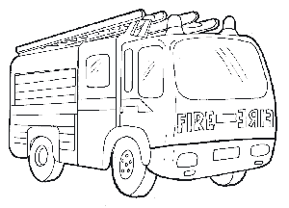  A fire engine | 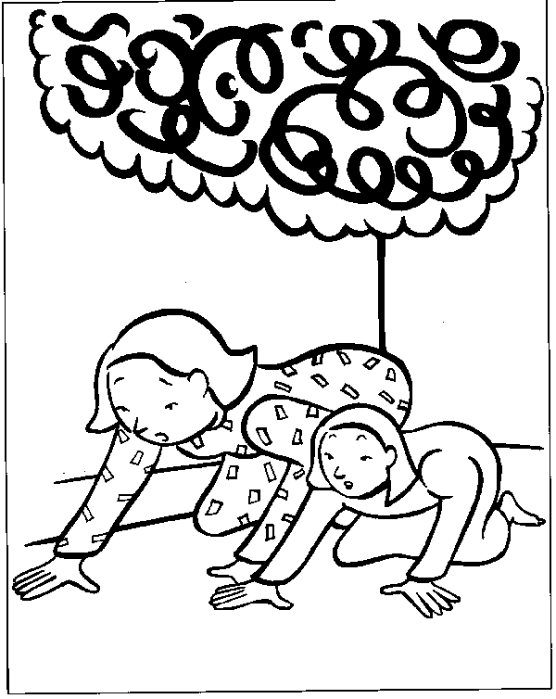  In a smoky room, crawl under the smoke
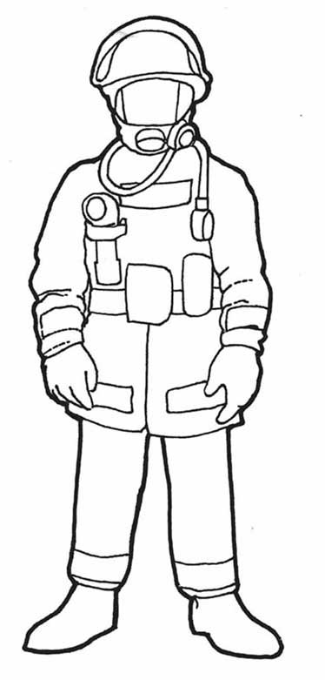  This is a fire fighter | 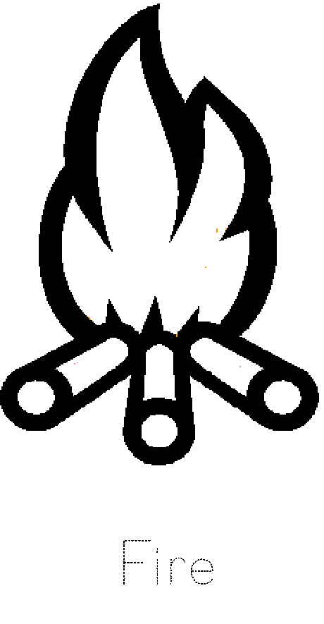  Fire burns you!
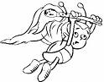  Frances the fire fly flying | 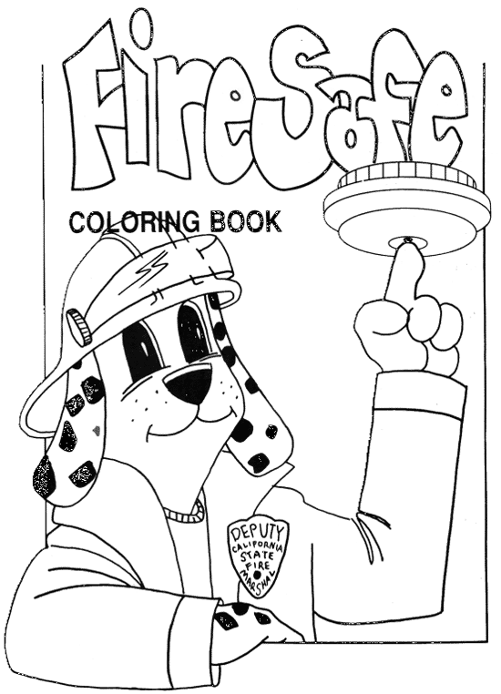  Sparky says,  ‘Check your smoke detectors regularly’

